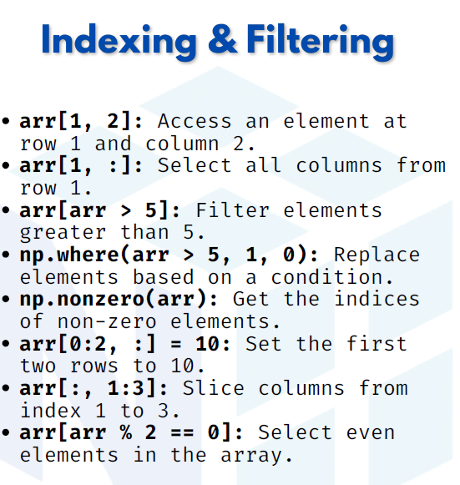

INDEXING AND filtering

1. arr[1, 2] → Access an element at row 1 and column 2
Indexing in NumPy works like a grid. Here, we select the element from 2nd row and 3rd column (since indexing starts at 0).

import numpy as np
arr = np.array([[1, 2, 3],
[4, 5, 6],
[7, 8, 9]])
print(arr[1, 2])

Output:
6

2. arr[1, :] → Select all columns from row 1
The colon (:) selects all elements in that axis. Here, we take the entire 2nd row.
print(arr[1, :])
Output:
[4 5 6]

3. arr[arr > 5] → Filter elements greater than 5
We can apply conditions directly to arrays. NumPy returns all elements that satisfy the condition.

print(arr[arr > 5])
Output:
[6 7 8 9]

4. np.where(arr > 5, 1, 0) → Replace elements based on condition
The np.where() function works like an if-else. If condition is true → 1, else → 0.

print(np.where(arr > 5, 1, 0))
Output:
[[0 0 0]
[0 0 1]
[1 1 1]]

5. np.nonzero(arr) → Get indices of non-zero elements
This function returns the row and column indices of all non-zero values in an array.

arr2 = np.array([[0, 2, 0],
[3, 0, 4]])
print(np.nonzero(arr2))
Output:
(array([0, 1, 1]), array([1, 0, 2]))

6. arr[0:2, :] = 10 → Set the first two rows to 10
We can assign values to a slice. Here, the first 2 rows are set to 10.

arr_copy = arr.copy()
arr_copy[0:2, :] = 10
print(arr_copy)
Output:
[[10 10 10]
[10 10 10]
[ 7 8 9]]

7. arr[:, 1:3] → Slice columns from index 1 to 3
We take all rows (:) and select columns from index 1 to 2 (1:3).
print(arr[:, 1:3])
Output:
[[2 3]
[5 6]
[8 9]]

8. arr[arr % 2 == 0] → Select even elements in the array
We apply a condition to select only even numbers.

print(arr[arr % 2 == 0])
Output:
[2 4 6 8]

